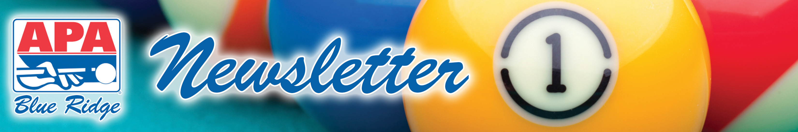

March 24, 2014: Volume XVIII – Issue 11

CUE TIP OF THE WEEK: DRESS CODE
Believe it or not, the APA actually does have a dress code. We aren't asking folks to dress in their Sunday best, but we do ask that you dress appropriately to be in public. Ours is not a strict dress code, but does require shirts that are not tattered and torn, shoes in all locations that serve food, pants or shorts that fit and do not hang down so far we can see the moon (or even a sliver of the moon), and please – no offensive clothing that spouts political, ethnic, or religious views that might be offensive to others.


THIS WEEK’S BOUNTY HUNT:
Phil Dyment from “Fire Hazard” – there’s a bounty on your head this week. Play and win your match this Monday and your match is free! If his opponent (the bounty hunter) wins, then the bounty hunter plays for free!

BREAKING DOWN A POOL CUE
There once was a rule about conceding a match if a player breaks down his or her pool cue before the match is officially complete – or WAS there...? This is a myth. There is no such rule – in other words, it is NOT a foul to break down a cue while the match is still being played.

It might be deemed by some players bad sportsmanship to break down your cue before the match is complete. Well, this all depends on the players, the circumstances, etc... so exercise your best judgment here without being disrespectful to your opponent or your team. Besides, we encourage players not to give up so easily, as it ain't over until it's over, ya know?

JACK & JILL ANNOUNCEMENT – THIS WEEKEND!
City Billiards on Sunday, March 30th
Doors open at 12:00pm. Tournament starts at 1:00
$40 Pre-Registration per Team / $45 Registration Day of Tournament

Team Name:_______________________________

Player #1: _________________________________

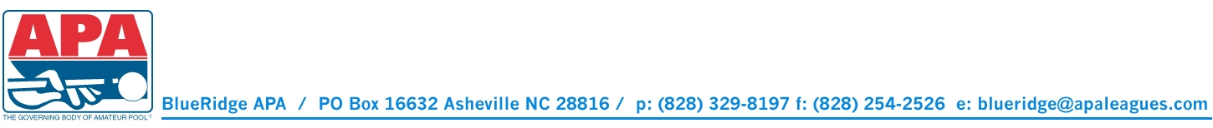
Player #2: _________________________________

